**Clean Duplicate Data and Null Records from SQL Database Table**

**Objective**  
The goal of this project is to clean a given SQL database table by identifying and separating duplicate and null records into distinct categories: good records and bad records. The cleaned data will then be exported to two separate CSV files.

#### **Instructions**

1. **Analyze the SQL Database Table**
   * Inspect the given table and identify columns with duplicate and null values.

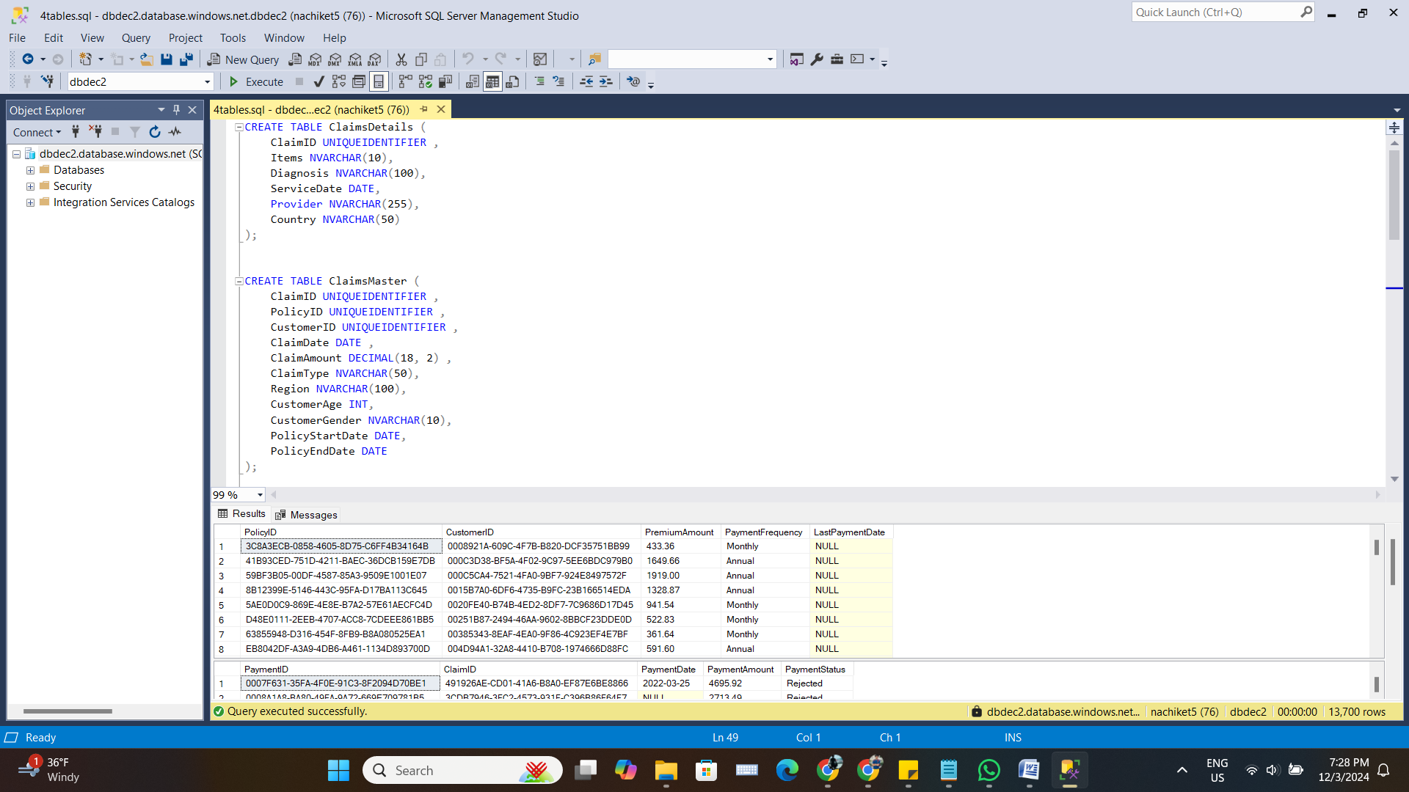

* + Understand the schema and determine which columns are critical for identifying good records.

For analysis dates are important for my final business growth insights so i should not use validdate column to remove nulls from date columns.

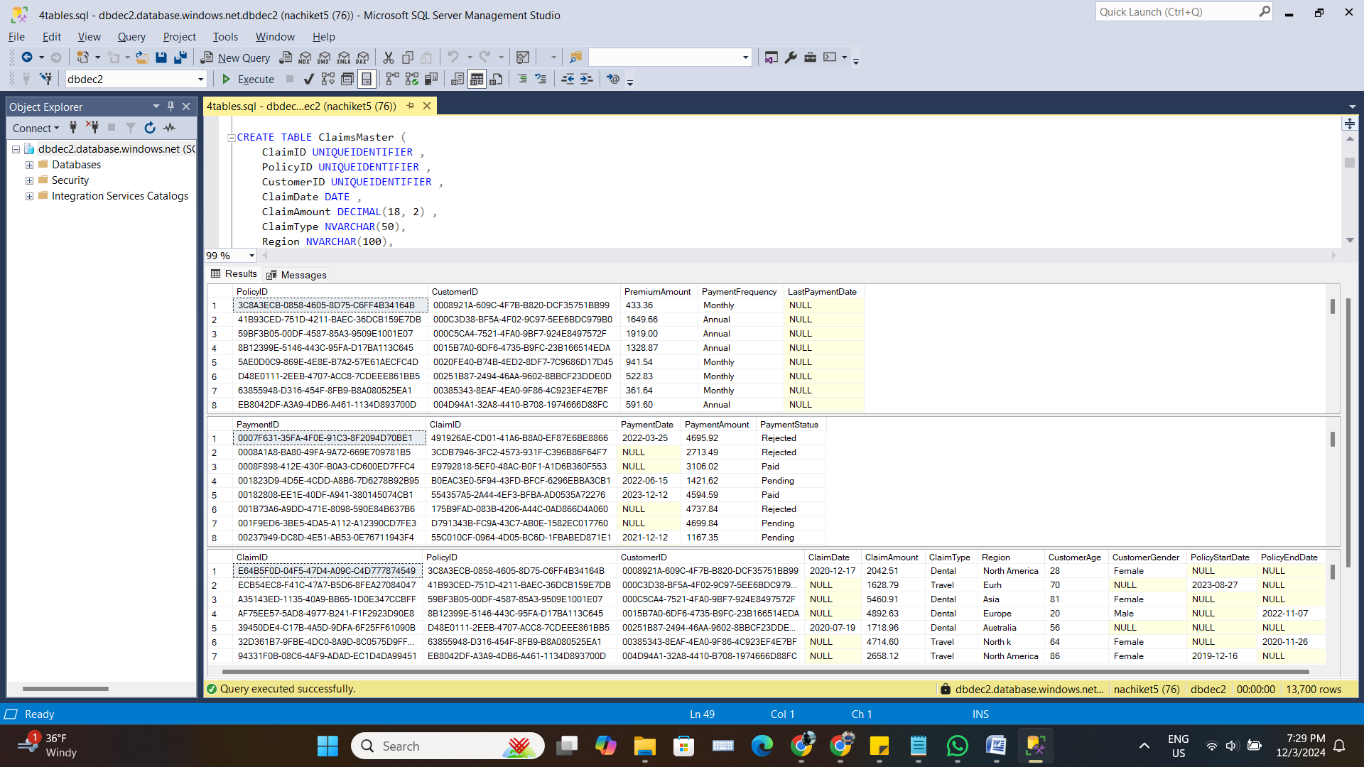

1. **Perform Data Cleaning**
   * Remove duplicate records from the dataset based on specified columns.

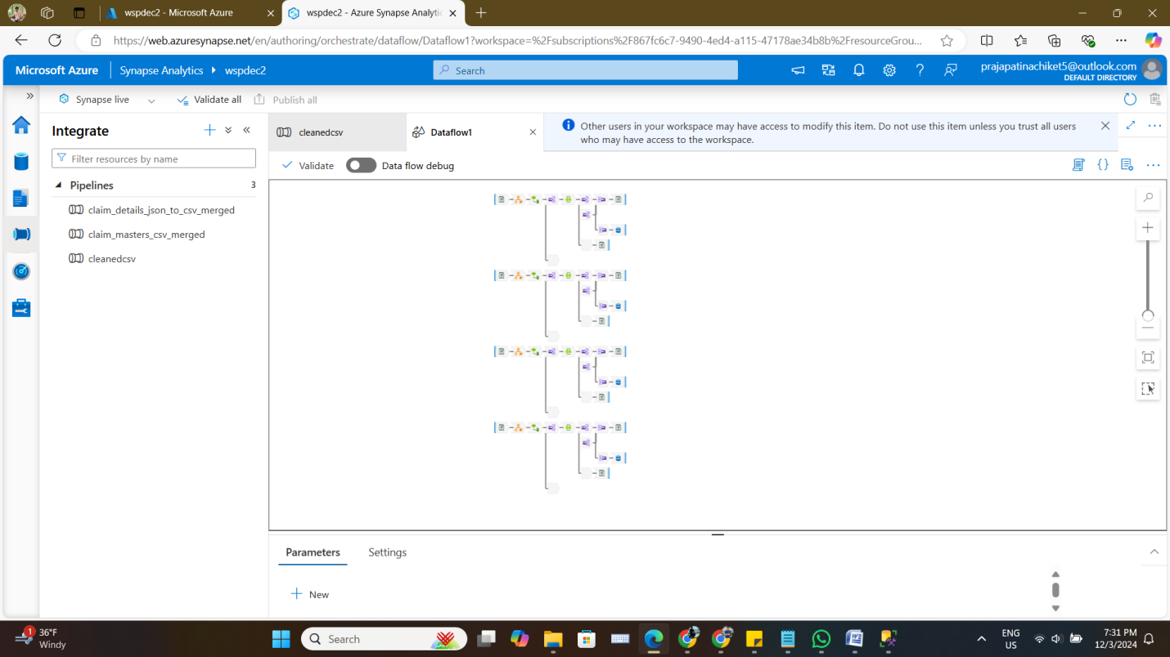

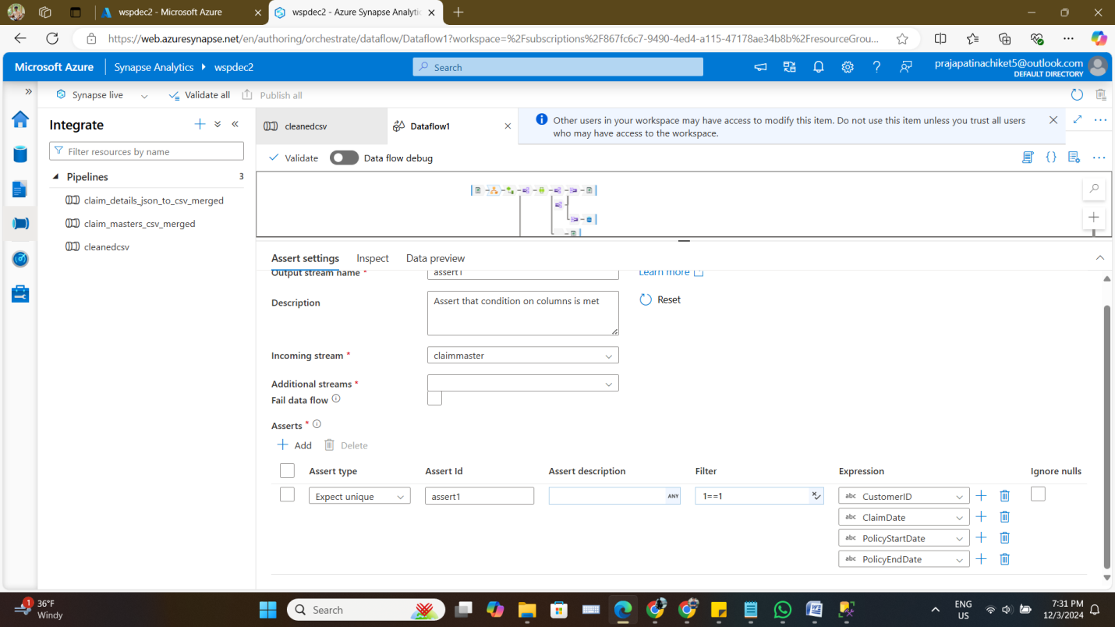

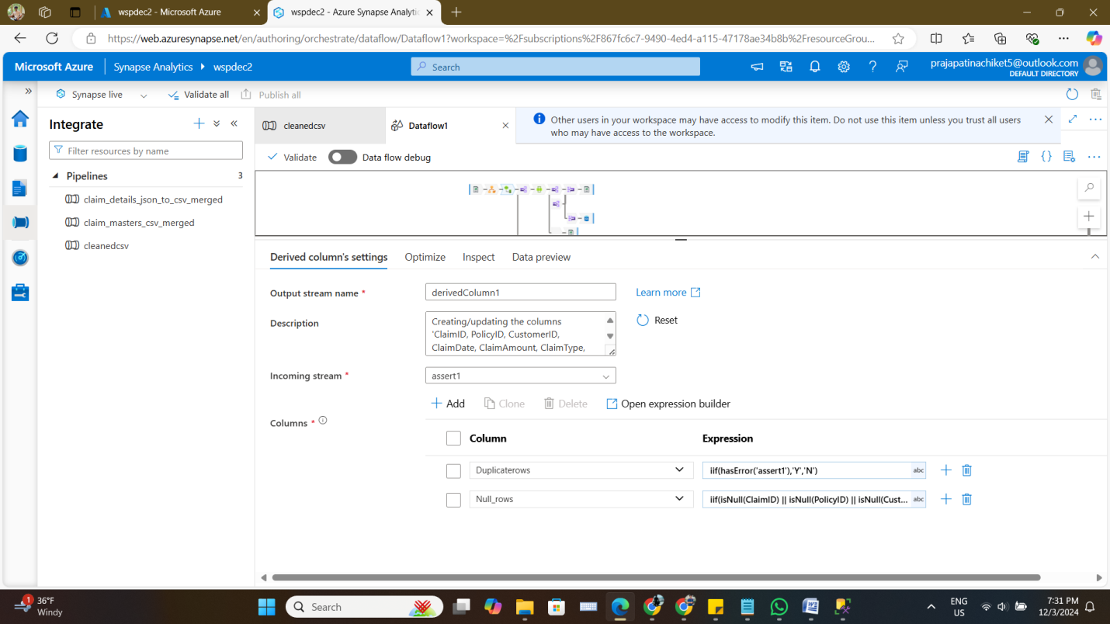

* + Identify and segregate records containing NULL values in any of the critical columns.

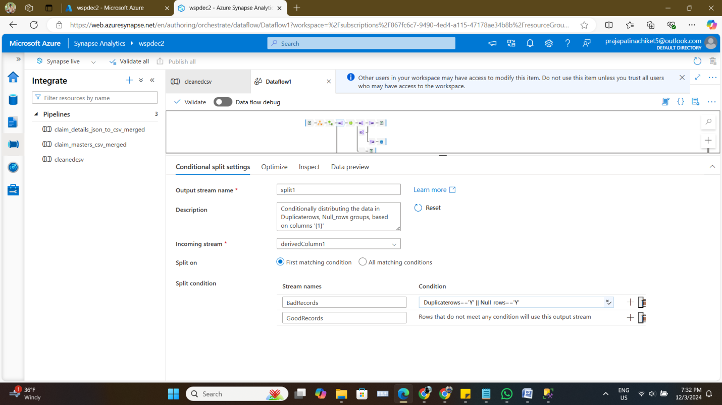

**Window**

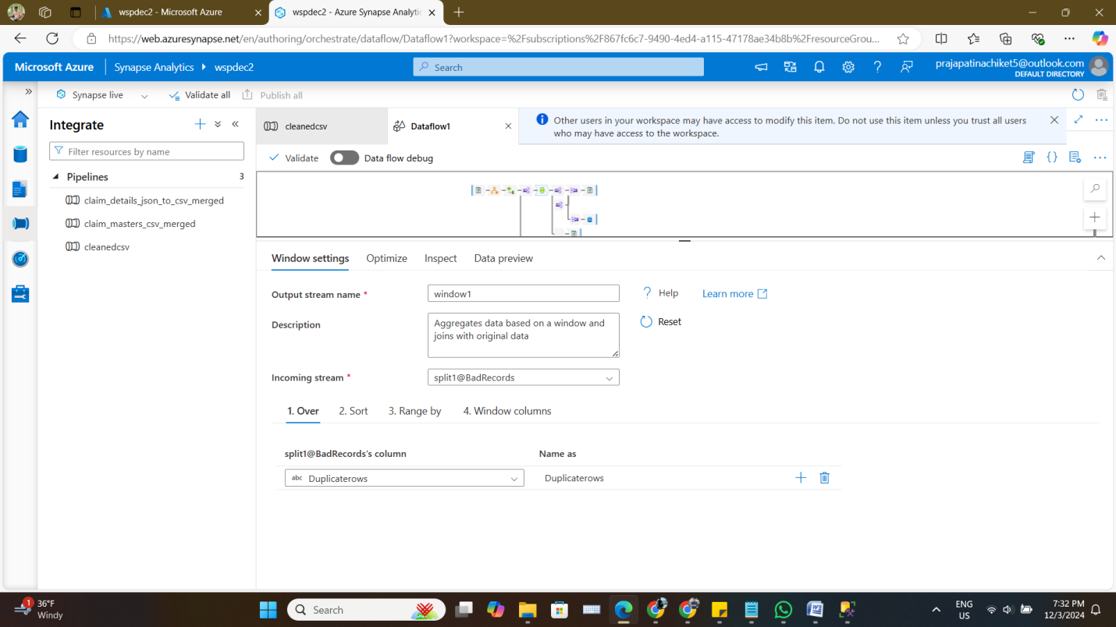

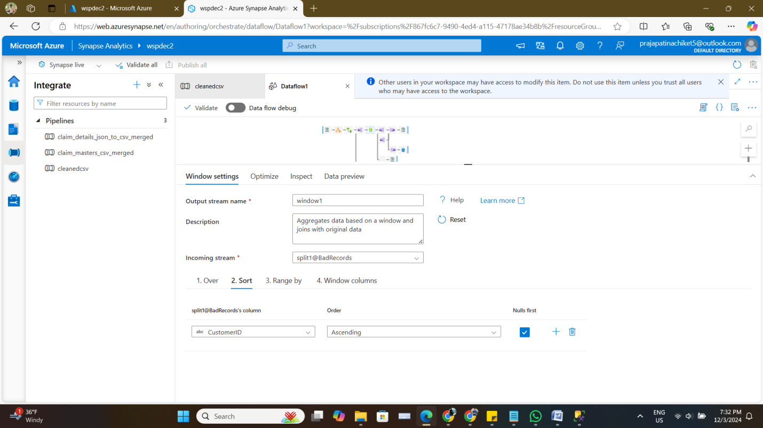

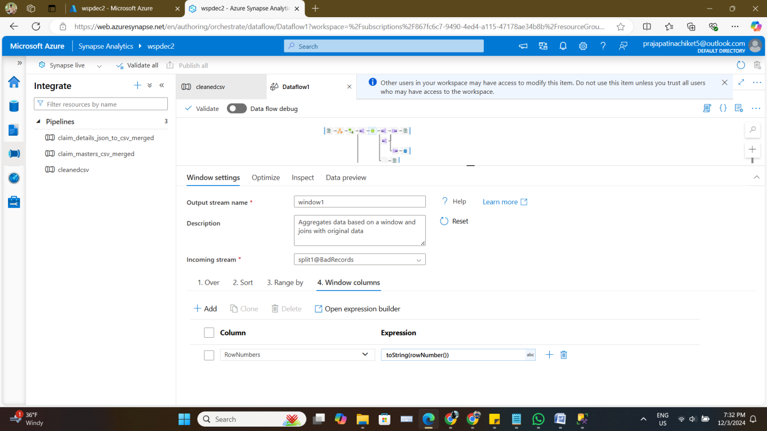

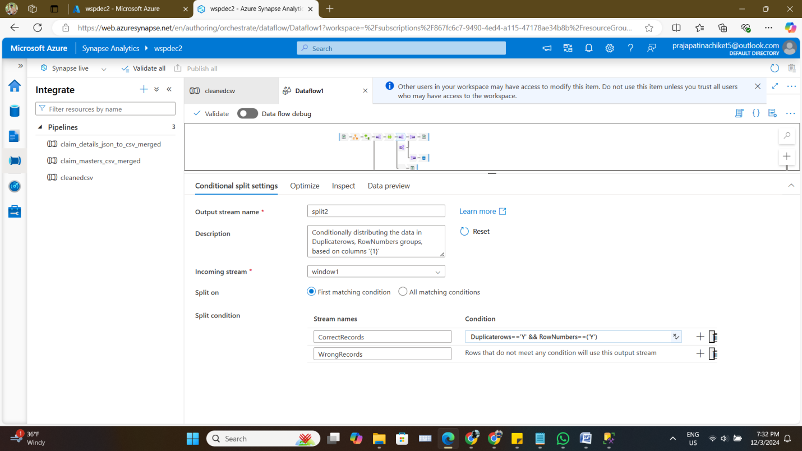

**Union**

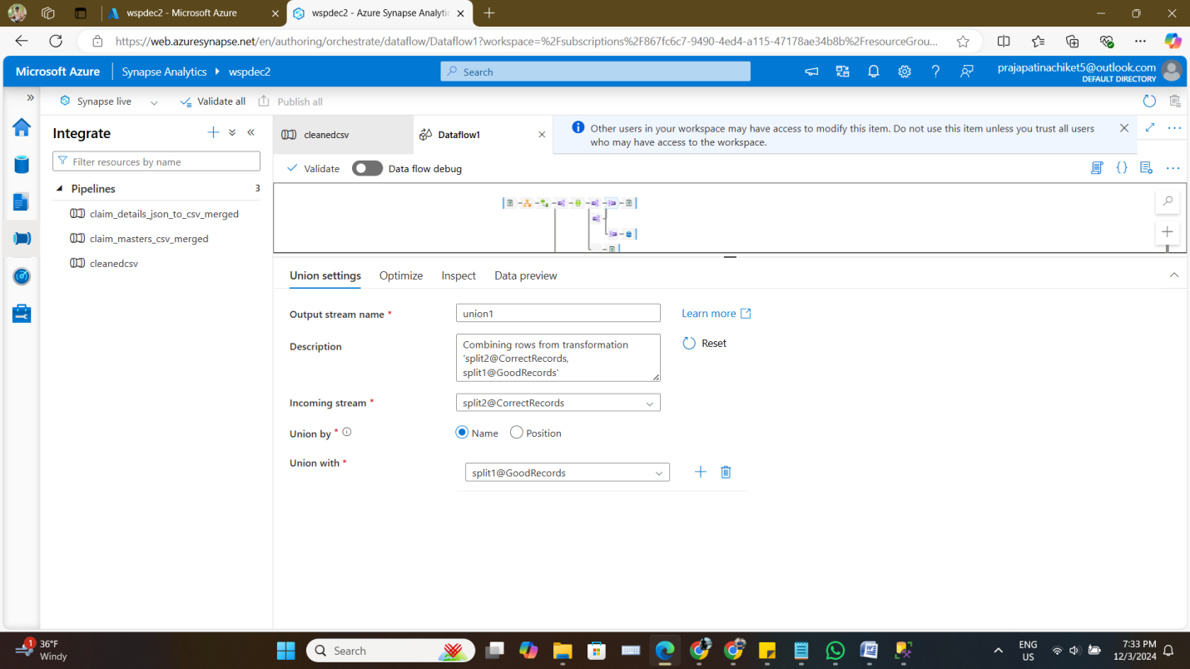

1. **Export Cleaned Data**
   * Export all good records (cleaned and valid) into a good_records.csv file.

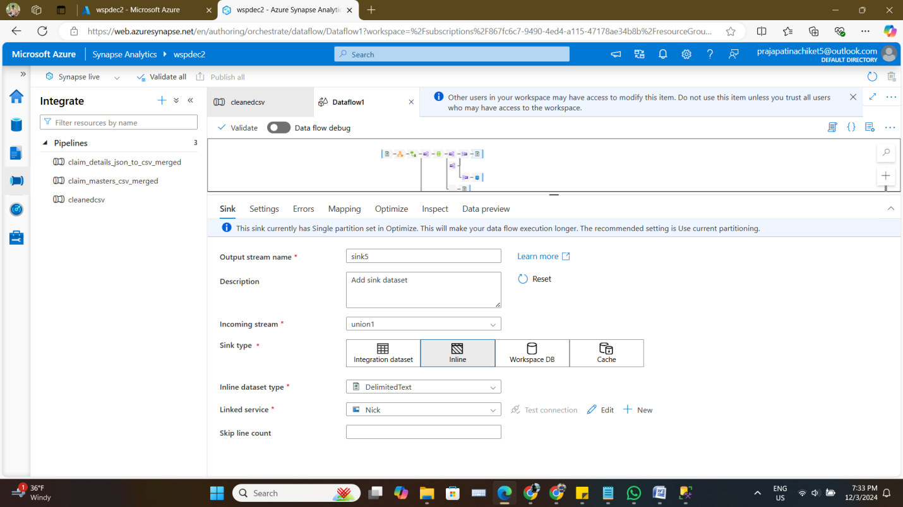

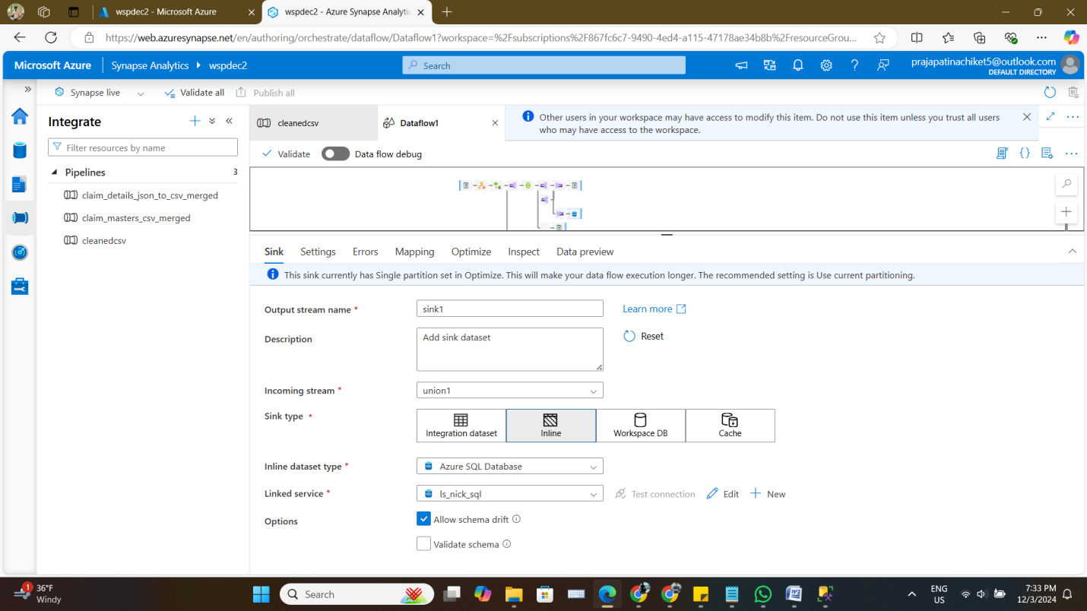

* + Export all bad records (duplicates and records with null values) into a bad_records.csv file.

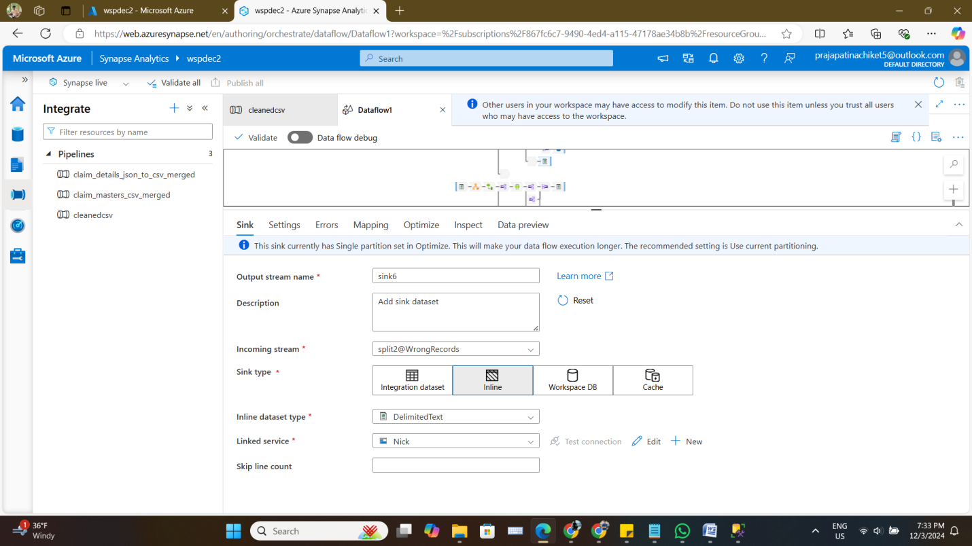

1. **Verify Output**
   * Validate the CSV files to ensure correct segregation and cleaning of records.

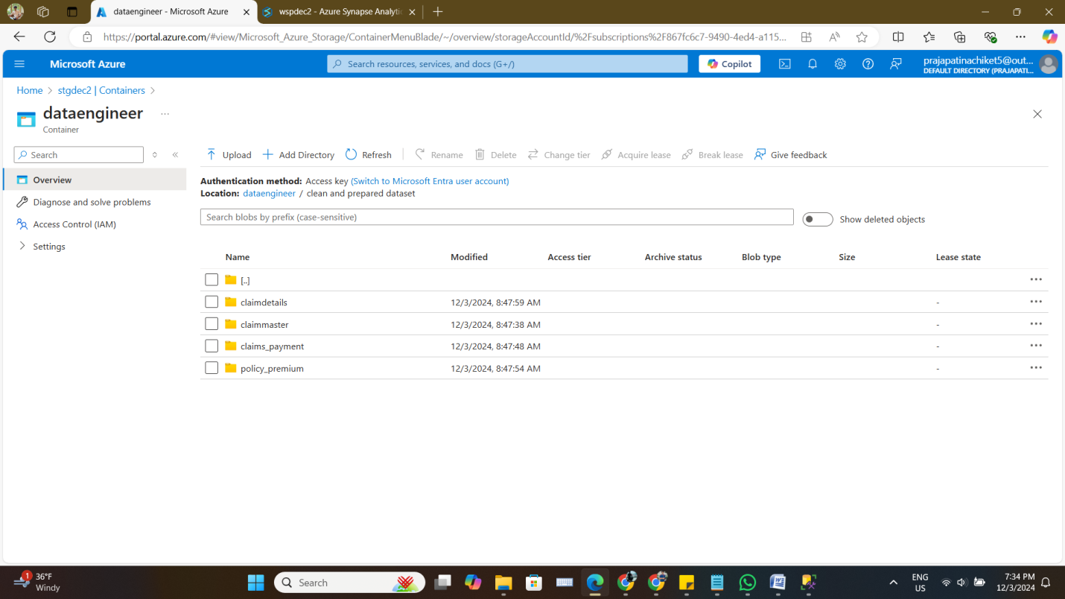

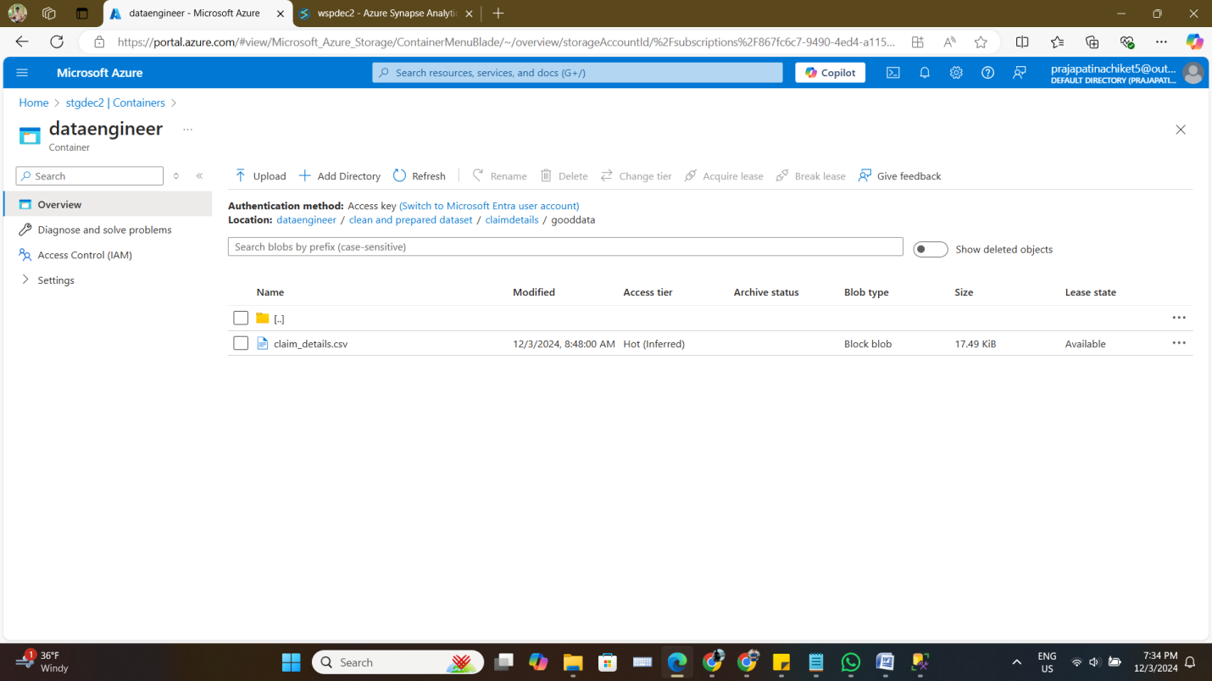

* + Ensure the good records meet all the criteria for completeness and uniqueness.

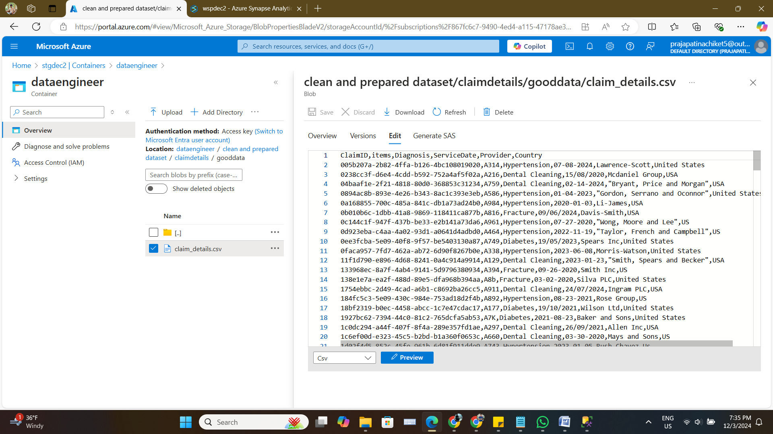

#### **Expected Output**

1. **good_records.csv**
   * Contains all cleaned records without duplicates or null values.

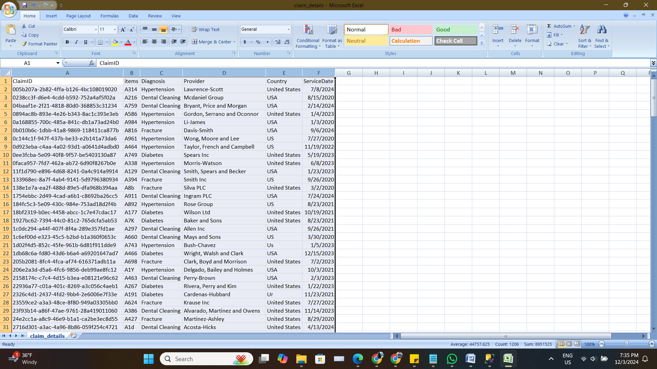

* + Each record should represent valid and unique data.

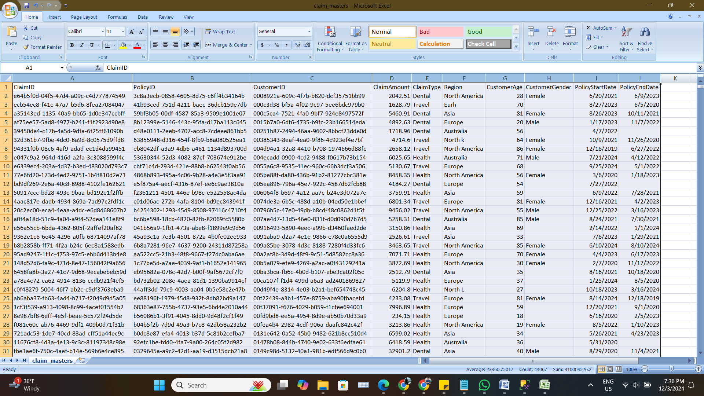

1. **bad_records.csv**
   * Contains all records flagged as duplicates or containing null values.

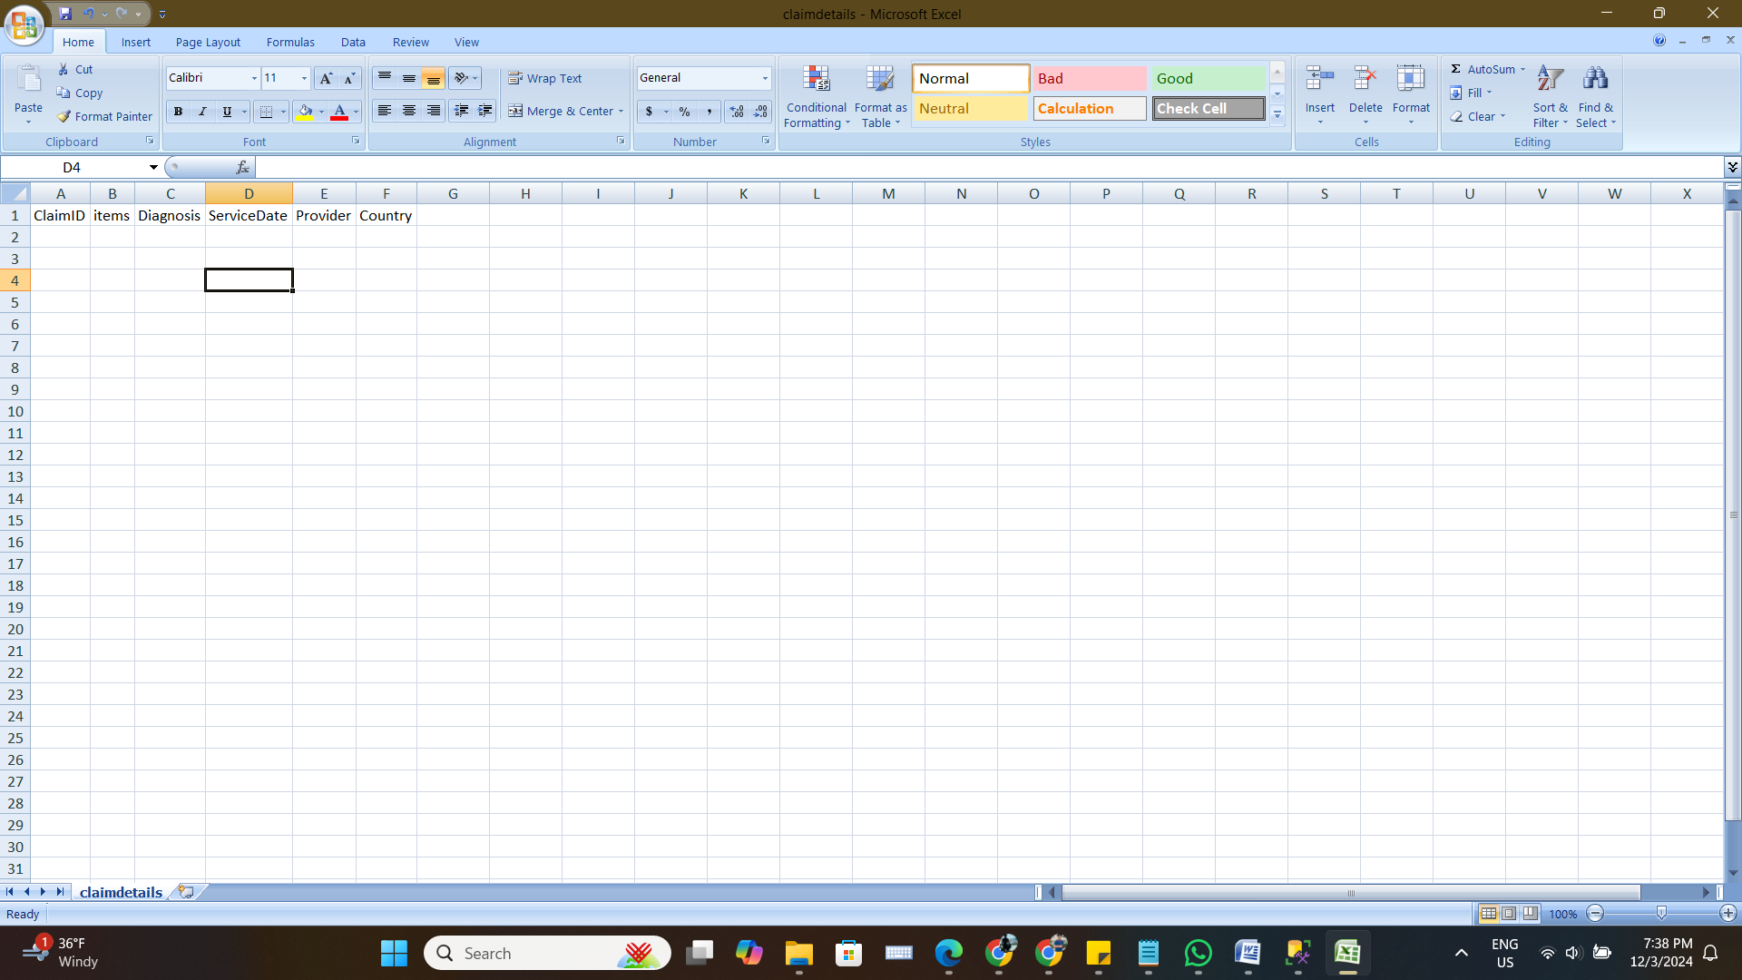

* + Each record should indicate why it was classified as a bad record (e.g., Duplicate, Null Value).

It is not showing because of validdate column, in the end i will need that date column for analyzing five objectives for business ingsights